**ITEM THREE**

**SCIENCE**

*Time : 2:15minutes*

**Candidate ’s name :…………………………………………… Stream……………........**

**Index No.…………………………………………………………………………….**

**SECTION MARKS**

**B**

**A**

**DO NOT OPEN THIS BOOKLET UNTIL YOU ARE TOLD TO DO SO**

**Read the following instructions carefully.**

**T**

1. **Read the instructions carefully**

1. **Answer ALL questions in Section A & B**
2. **Answers should be put in the space provided.**
3. **All answers should be written in blue or black ink.**
4. **Unnecessary alterations may lead to loss of marks**
5. **Any handwriting that cannot be read may lead to loss of marks.**

**SECTION A (40 MARKS)**

1. Name any one material used to clean our teeth.

_________________________________________________________

1. Mention any one raw material used by plants to make food.

_________________________________________________________

1. How are eagles adapted to their mode of feeding?

_________________________________________________________

1. Why are perches put in a poultry house?

_________________________________________________________

1. Which excretory product is removed from the body by the kidneys?

_________________________________________________________

1. State any one characteristic common to all insects.

_________________________________________________________

1. Give the meaning of pitch as used in sound energy.

_________________________________________________________

**The diagram below shows a garden tool.**

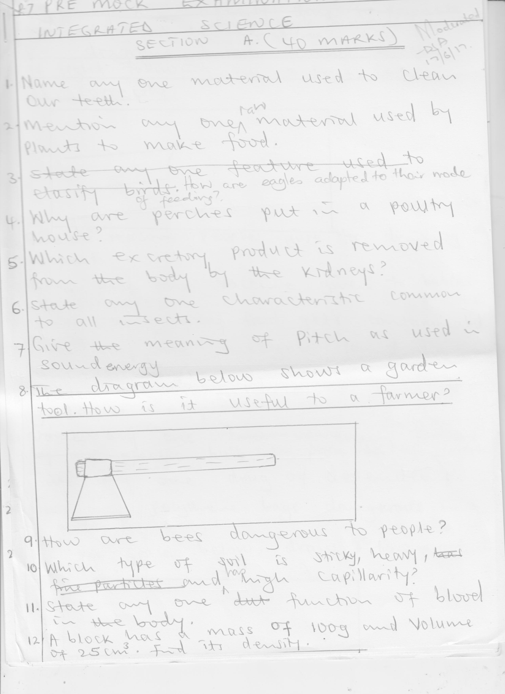

1. How is the above tool useful to a farmer?

_________________________________________________________

1. How are bees dangerous to people?

_________________________________________________________

1. Which type of soil is sticky, heavy and has high capillarity?

_________________________________________________________

1. State any one function of blood in the body.

_________________________________________________________

1. A block has a mass of 100g and volume of 25cm**3**. Find its density.

_________________________________________________________

1. What type of weather supports farmers to plant their crops?

_________________________________________________________

1. Why are people encouraged to smoke their pit latrines?

_________________________________________________________

1. **The diagram below shows a beam of light falling on a lens. Complete it correctly**

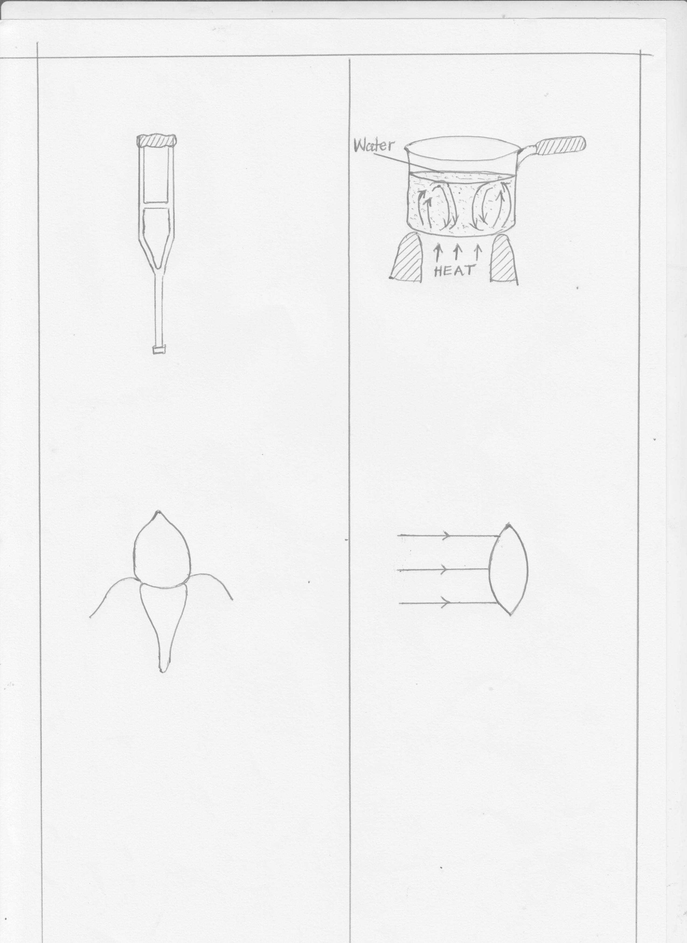

1. Give one reason people give for drinking alcohol.

_________________________________________________________

1. Name any one vaccine given to babies at 10 weeks.

_________________________________________________________

1. State one way food gets contaminated.

_________________________________________________________

1. Identify any one enzyme found in pancreatic juice.

_________________________________________________________

1. State one importance of a school garden to a P.7 pupil.

_________________________________________________________

_________________________________________________________

1. Name any one energy change that takes place when an electric bulb is turned

on.

_________________________________________________________

1. Give any one drug of dependence.

_________________________________________________________

1. How are polythene bags dangerous in a garden?

_________________________________________________________

1. In the space below, draw the fibrous root system

1. State one way of controlling tape worm infestations for P.4 pupils.

_________________________________________________________

1. Cite one example of a floating object.

_________________________________________________________

1. Why is a fern able to make its food?

_________________________________________________________

1. Name any one example of a crop that stores food in its aerial stem.

_________________________________________________________

1. The diagram below shows a tooth.

How important is the above tooth to people?

_________________________________________________________

1. Which method of grazing animals is common to farmers in urban areas?

_________________________________________________________

1. State one way of caring for plants in our compounds.

_________________________________________________________

1. State one disadvantage of using electricity in lighting our school.

_________________________________________________________

1. State one way bacteria is useful to people.

_________________________________________________________

1. Why is the trachea covered with rings of cartilage?

_________________________________________________________

_________________________________________________________

1. Identify one blood disorder common among children in Uganda today.

_________________________________________________________

1. Give any one salt lost during dehydration.

_________________________________________________________

1. What type of change is pigmentation?

_________________________________________________________

1. Name one method of making water clean for home use.

_________________________________________________________

1. Identify any one vector that spreads diseases by biting.

_________________________________________________________

1. Why is turpid sponging encouraged among children with fever?

_________________________________________________________

**SECTION B (60 MARKS)**

1. a) Why do farmers keep Saanen goats.

_____________________________________________________

_____________________________________________________

b) How do crop farmers benefit from rearing goats?

_____________________________________________________

c) What is shearing as used in sheep rearing?

_____________________________________________________

_____________________________________________________

d) State one importance of docking sheep

_____________________________________________________

1. **The diagram below shows a VIP latrine. Use it to answer questions**

**that follow**

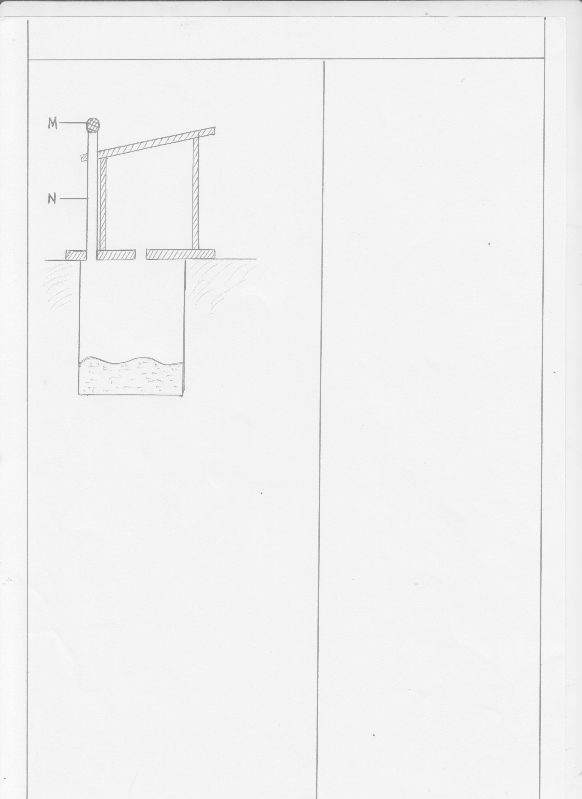

a) Name parts M and N

i) M ________________ ii) N ____________________

b) Why is the hole of a VIP latrine not covered?

___________________________________________________

c) How can we care for the above facility at school?

_____________________________________________________

1. a) What are Energy Resources?

_____________________________________________________

_____________________________________________________

b) Name two examples of Energy Resources in the environment.

i)____________________________________________________

ii)___________________________________________________

c) Which type of fuel is got from plants?

_____________________________________________________

1. a) State any two uses of food in the body.

i) ___________________________________________________

ii) ___________________________________________________

b) Identify one food source of Vitamin A.

_____________________________________________________

c) Which deficiency disease is caused due to lack of iron in the body?

_____________________________________________________

1. a) State any two advantages of breast feeding to babies.

i)____________________________________________________

ii)___________________________________________________

b) Why should breast feeding mothers take a lot of fluids?

_____________________________________________________

c) When may a baby be prohibited from breast feeding?

_____________________________________________________

1. a) What is Menstruation?

_____________________________________________________

_____________________________________________________

b) Name any two primary sex change in girls.

i) __________________________________________________

ii) __________________________________________________

c) How can a young girl maintain good personal hygiene during

menstruation?

_____________________________________________________

_____________________________________________________

1. **The diagram below shows a method of making magnets. Use it to**

**answer questions that follow:**

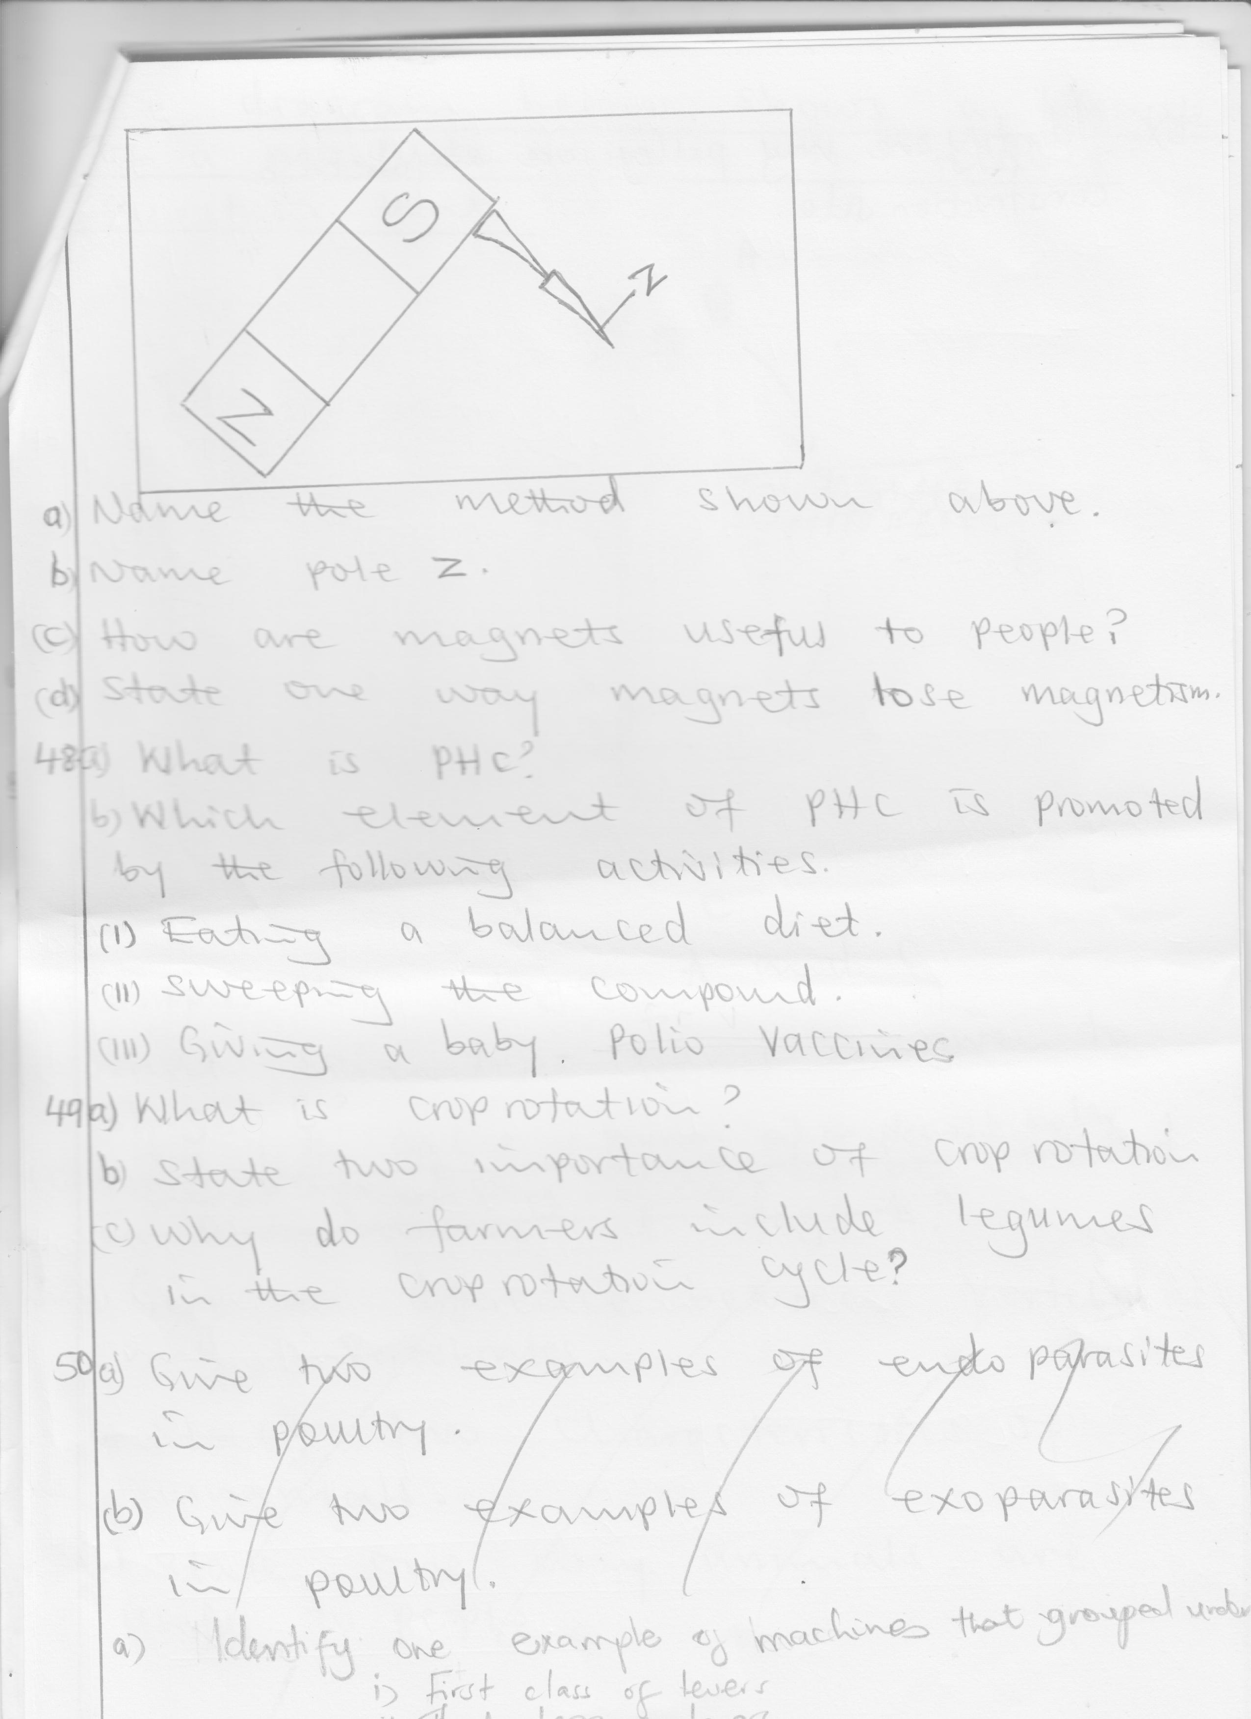

1. Name the method shown above.

_____________________________________________________

1. Name pole Z.___________________________________________
2. How are magnets useful to people?

_____________________________________________________

1. State one way magnets lose their magnetism.

_____________________________________________________

1. a) What is PHC?

_____________________________________________________

b) Which element of PHC is promoted by the following activities.

i) eating a balanced diet.

_____________________________________________________

ii) sweeping the compound _____________________________________________________ iii) giving a baby polio vaccine _____________________________________________________

1. a) What is crop rotation?

_____________________________________________________

_____________________________________________________

b) State two importance of crop rotation.

i)____________________________________________________

ii)___________________________________________________

c) Why do farmers include legumes in the crop rotation cycle? _____________________________________________________

1. a) Identify one example of machines that are grouped under
2. first class of levers.

____________________________________________________

1. third class of levers

____________________________________________________

1. wedges

____________________________________________________

b) Identify one way pulleys are useful on a construction site.

_____________________________________________________

1. 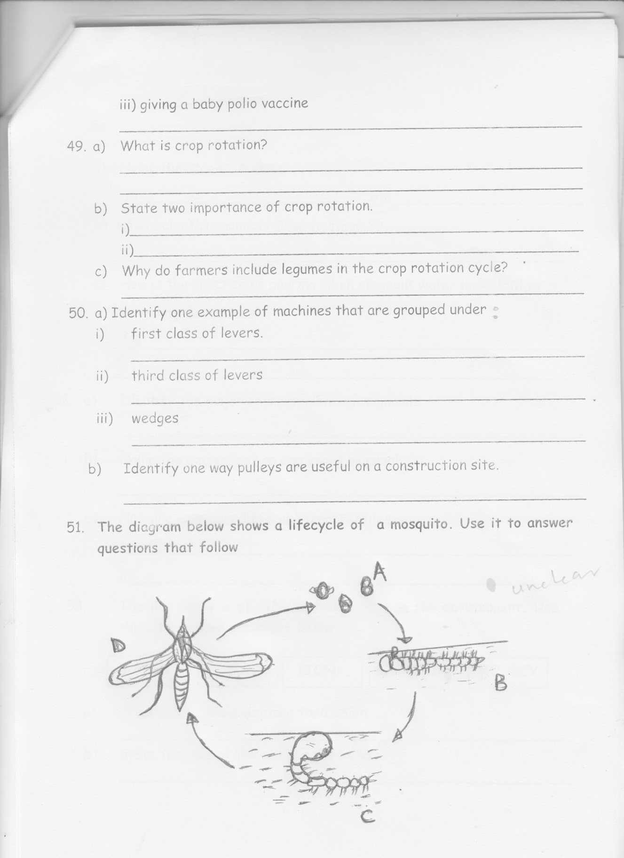**The diagram below shows a lifecycle of a mosquito. Use it to answer questions that follow**
2. Name the stages A and C.
3. A _______________________
4. B _______________________
5. What scientific name is given to stage B?

_____________________________________________________

1. How is the practice of pouring oil on stagnant water important while controlling mosquitoes?

_____________________________________________________

_____________________________________________________

1. a) Identify the major characteristic of mammals.

_____________________________________________________

b) Name one example of an egg laying mammal.

_____________________________________________________

c) How are mammals different from reptiles

i)____________________________________________________

ii)___________________________________________________

1. **The list below is of different organisms in the environment. Use**

**them to answer questions below**

**MAIZE SUN LION BACTERIA MONKEY**

1. Arrange the above list as a food Chain.

____________________________________________________

1. State the role of the sun in a food Chain.

____________________________________________________

c) Name the primary consumer in the above list.

_____________________________________________________

d) How is bacteria useful in a food Chain?

_____________________________________________________

1. a) Name two process involved during distillation of alcohol.

i)____________________________________________________

ii)___________________________________________________

b) Give any one use of alcohol to people.

_____________________________________________________

c) How is alcoholism dangerous to people?

_____________________________________________________

1. **The diagram below is of the heart. Use it to answer the questions**

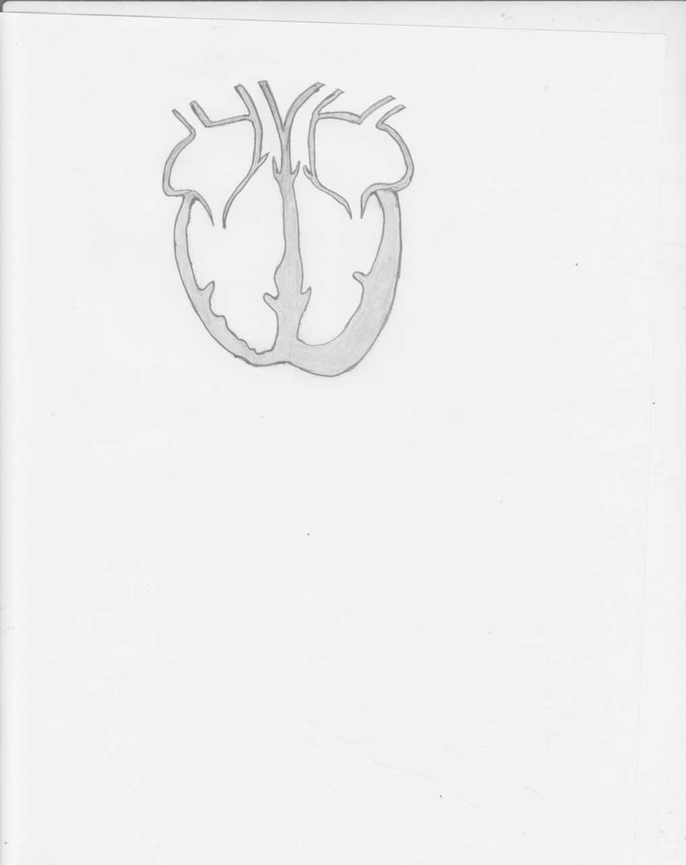 **below.**

**P**

**Q**

**X**

**Y**

1. Name the blood vessels labeled P and Q.

i)P________________________ ii)Q_____________________

b) Why is part X thicker than Part Y?

_____________________________________________________

c) Name one activity done to promote proper functioning of the above

organ.

_____________________________________________________**END**